Li, Benjamin
[Email address]
Abstract
[Draw your reader in with an engaging abstract. It is typically a short summary of the document.
When you’re ready to add your content, just click here and start typing.]
[Document title]
[Document subtitle]

Contents
Analysis 2
Project Overview 2
Current Systems 2
End Users, Interviews and Questionnaires 2
Proposed Solutions 6
List of objectives 6
Hardware and Software requirements 10
Documented Design 11
Interface 11
Testing 28
Test 2 28
Evaluation 31
List of objectives – Reflection 31
Research (organise this later) 34
C# Tutorial - SuperSimple TCP/IP Client Server | FoxLearn - YouTube 34
GitHub - dwyl/english-words: :memo: A text file containing 479k English words for all your dictionary/word-based projects e.g: auto-completion / autosuggestion 35
Bibliography 36

Analysis

Project Overview
For this NEA Computer Science A-Level project, I will be coding a simple singleplayer word-based video game. The premise of this game is

Controlled studies have shown that video game formats of education can strengthen learning by enhancing attention, engagement, motivation and participation (Juho Hamari, 2014). While this style of education has been present for a large chunk of human history

Current Systems

End Users, Interviews and Questionnaires
My end users of my project will be people who enjoy word-based games and people who wish to improve and challenge their vocabulary, or both. My target audience is important to keep in mind for this project because it affects the very design of this game. It should be designed in a way to help people learn and familiarise themselves with a language’s vocabulary.

Interview
To ensure my overall goal with this project is achieved to a high enough of a standard as possible, I’ve interviewed one of my online friends who is extremely well-accustomed to word-based video games and has had experience with a variety of puzzles, problem-solving games and word games. This interview with them was to look for ideas on the format of the game which through other people’s experiences have found to have provided a fun and engaging experience while also providing opportunities for players to learn. These conversations have been summarised in the table below:
Point | What I’ve learnt from it
“also there could be easy as hell picks like if the word is plural, instant 14 letter word”  This is a point saying that if the program gives the player a word that isn’t in its root form, it would give them an incredibly obvious word to start off with. | The circumstance described here can be a problem as it may inadvertently cause players to think less rather than more and causing them to take more shortcuts, sticking to words they are already familiar with. This goes against the overall objective of this project in the first place and to help tackle this I’ve suggested an option to make prompts exclusively root words (no plurals, no past participles, no antonyms), meaning players will have to think more with their selection of characters, however there’s no hard-and-fast way to filter out all non-root words from a word list, and this can cause many false positives.
“timed mode like tetris 40 line sprint”  The suggestion of a timer-based gamemode where the player gets an extra challenge to name as many words as they can within a specified time limit. | The extra challenge of a time limit can help bring a significant benefit to the players’ learning experiences. A timer will make for a faster-paced, high-pressure experience which can help boost attention and information retention, which helps to fulfil my project’s intended purpose. Players who end up running out of words before the timer ends can be encouraged to look through the list of missed words with curiosity and can help solidify their knowledge of words less familiar to them, or can help them learn new words.  Additionally, during the game they may also be encouraged to look at words with more scrutiny, potentially helping them find new ways of looking at words which can help with language acquisition and reading comprehension – a benefit that players who run out of time before words can face too.  This suggestion is also interesting because this had made me realise that of all the open-ended active recall-based games I’ve looked towards during my research of current systems, almost none of them had a built-in time limit. Many people who have made content showcasing and playing with these systems have had to use an external source for their time limit, such as their phone. Therefore, I think including a timer built-in with this program can help with accessibility and can also open the door towards more customisable playstyles and options later down the road.
No clear quote available  A suggestion to add a feature where a player can click on any word and it brings up their official definition from a dictionary source. | This is extremely helpful towards achieving the goal of this project. Many words that the program could give the player as a prompt are words that the player has never heard of, especially words which don’t seem to look like words at all. Naturally for a lot of people, they will want to know what the word means and how they can use it in communication, and while it is only just a short google search away, an extra button in the menu which brings up a selected word’s definition fetched from online sources in the program itself can help significantly with accessibility and can make the user experience much smoother.
“how it works is you go around the table and gotta come up with words that use the first letter(s) of the word the last person put”  This is the description of a multiplayer fast-paced word game called “Last Letter” where a player must name a word beginning with the letters of the last letters of the previous player’s word. An example given by the interviewee is “LOCK -> KAYAK -> KOALA -> LATEX -> EXCESS” | This isn’t a direct suggestion however the mentioning of this game and its premise has brought about several ideas for this program. Firstly, a “string mode” as I would eventually come to call it later that day, which uses the idea of Last Letter in which any word the player lists must begin with the last letter of the previous word. This could help encourage the player to think more to come up with words with the extra challenge and the list of missed words would be modified to only show missed words beginning with the last letter of the player’s last input, which would help with making the list more digestible and could promote learning. Additionally, this gamemode could also help with improving their language awareness by encouraging them to think about their words in advance to avoid accidentally getting themselves in tricky situations where they are forced to come up with words beginning with rare letters.  Additionally, the mentioning of another multiplayer fast-paced word game has brought about another idea to my mind which can potentially help bring the nature of this game closer to that of a fast-paced multiplayer game whilst still being singleplayer. Expanding on the timer feature, a gamemode called “Dynamic Timer Mode” where with each correct input the timer value is increased by a specified increment value, similar to how players in multiplayer games are given a short time window (5-10 seconds) to name words with each turn, or else they are eliminated. This also helps to enhance the game’s progressive difficulty – naming new words becomes harder as you run out of words and with a strict time limit that depends entirely on how quickly you name words, this is made even harder. Therefore higher scores could feel more rewarding to players, and this extra engagement can help significantly with this game’s educational aspect as information retention is boosted if the player is more invested in the game.
This is a description of a browser game where the player is presented with randomised sequenced challenges and a very short time limit for each one. The player scores by successfully completing each challenge and the game ends when the player fails at one. The difficulty of each challenge progressively increases. | Similar to the point above, this isn’t a direct suggestion for the program but it has given some solid ideas for the development of this program, mainly expanding on the idea of progressive difficulty. A new gamemode I have devised with this idea works by giving the player a random prompt with each new correct input, but the list of words a player has inputted persists, meaning that once a player inputs a word they cannot use it again for the rest of the game. This works based on the progressive difficulty format in the sense that the more words you name and the further you get into a game, your options start becoming increasingly limited. This format can be paired well with the Dynamic Timer mode to create an especially high-engagement playing experience which can help the player learn and retain new words more easily and to raise their language awareness.

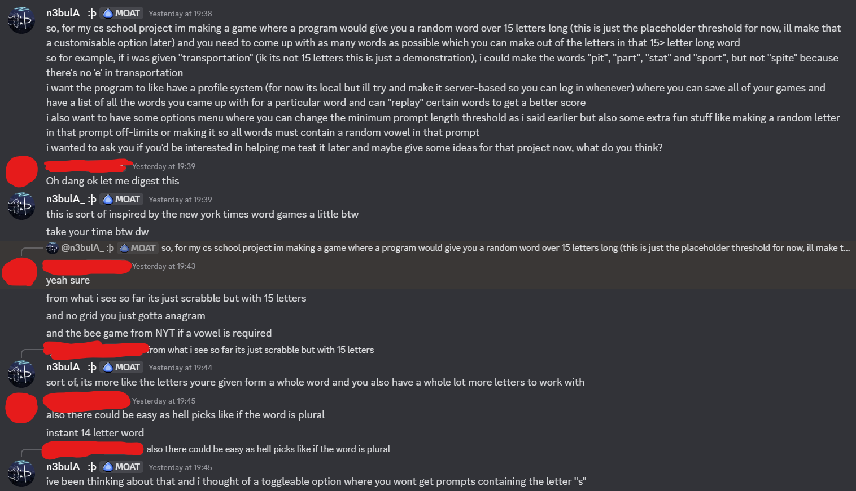
Figure 1 - Conversation Part 1
In Figure 1 the client highlights an important point where the program can select an alternative form of a word as the word prompt (such as plurals or past-tense verbs) making for an incredibly easy first guess. To help mitigate this I’ve considered adding a customisable option to exclude words ending in certain suffixes (e.g. -s, -tion or -ed) to avoid long words with easy guesses, though this could create some false positives where some regular words are excluded too. This is important because having instant easy guesses can hinder the learning experience and could inadvertently encourage players to take shortcuts, so limiting the pool of words to just root forms would force players to think more with their selection of characters.

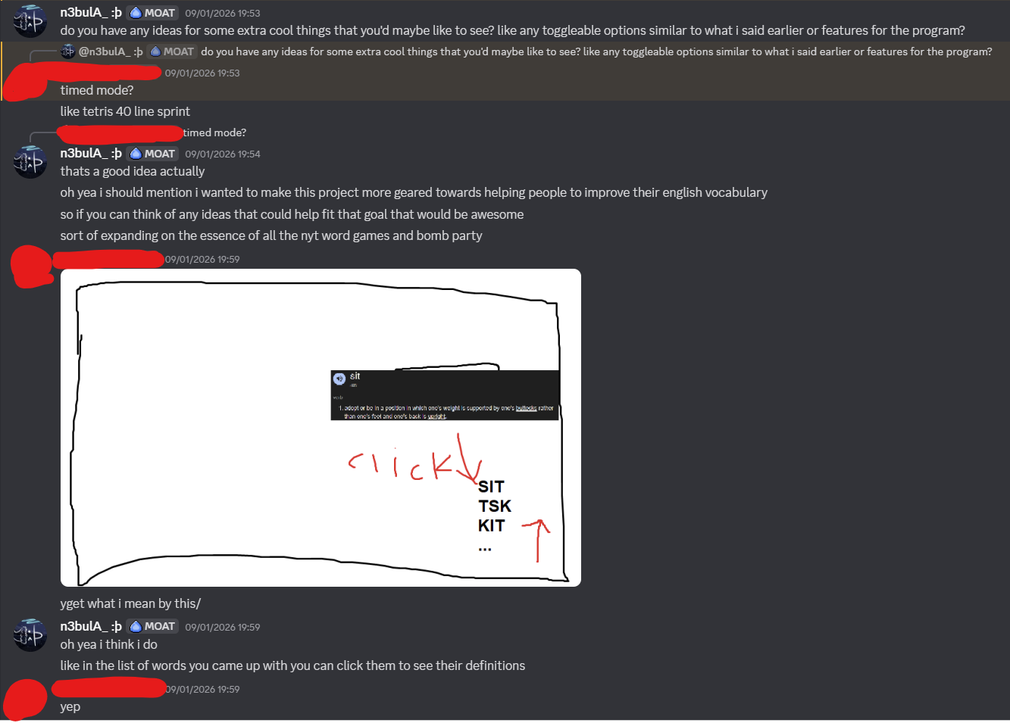
Figure 2 - Conversation Part 2
In Figure 2, the client suggests a timer-based mode, where an extra time limit challenge is added to the game where the player only has a limited time to come up with as many words as they can. Additionally, one feature they requested which I felt was perfect for my overall goal with this project is being able to click a word in the word list and it opens its definition(s), the source being most likely from an official dictionary website.
This suggestion has also given me an idea of having the program display all the valid words that the player missed after the game is finished and saved. This would help give the player an opportunity to learn new words and to help improve reading comprehension, especially among those who wish to improve at learning English as a non-native language.
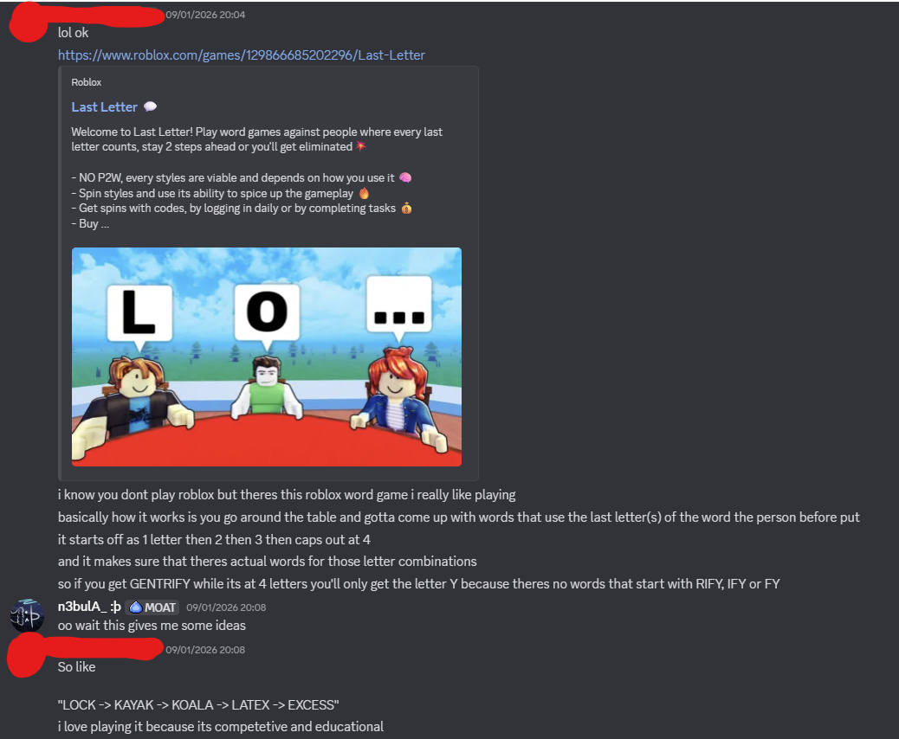
Figure 3 - Conversation Part 3
In Figure 3, the client gives an example of an online multiplayer game where the player must take turns to quickly come up with and submit a word that begins with the last letter of the previous player’s word input, with the number of letters your word must begin with depending on whether there are viable words beginning with said letters. This gave me an idea to add a new playstyle (which I would later refer to as “string mode”) into the program where each word you input must begin with the last letter of the previous input, meaning the player would have to think extra to name as many words as possible.
This playstyle can be combined with other aforementioned features in interesting ways. For example, upon further brainstorming, a dynamic timer gamemode could make for a fast-paced game where any valid player input adds a set time bonus to their timer, and this can be combined with the “string mode” gamemode to make for an even trickier gameplay experience. This can be taken a step further with the idea of displaying missed words – when the player eventually runs out of time in this gamemode, the program can display all the possible words the player could’ve inputted with the last input. All these features can be put together in such a way to maximise the potential for vocabulary acquisition whilst also making for an engaging gameplay experience which is crucial for helping newly learnt information to stick as long-term knowledge.

Proposed Solutions

Application
There are four main programs I could use to achieve the goal of this project, each with their pros and cons listed in the table below.
Application | Advantages | Disadvantages
Console application | - Very simple to code, requires almost no learning curve  - Less resource intensive | - No ability to create a meaningful user interface, making for an unpleasant user experience, as the program will have to constantly display feedback with each input making for a garbled mess of lines.
Windows forms application  (Selected) | - Allows for the creation of a highly customisable user interface, including the ability to use multiple forms in the same program – extremely desirable for getting a more positive user experience. | - These applications can only be run on devices running a Windows OS, making for an accessibility issue.
Browser application | - Can be accessed by any device as long as there is an internet connection, having the widest variety of devices which could run this program.  - Can easily be updated on the server-side so end users do not have to install manual updates to use the program’s latest version | - Requires an internet connection, potentially limiting accessibility.  - Requires a big learning curve as I would have to learn about server management and web development such as filetypes.
Mobile application | - More accessible as mobile applications can be accessed on a wider range of devices | - A touchscreen device may make typing each word significantly more tedious, detracting from the user experience  - Requires a big learning curve due to needing to accustom myself with platform-specific coding languages and developments for phone operating systems

Of all these options, I’ve decided to go with a Windows forms application. The console application’s inability to make a proper user interface makes it an unviable option for a video game instant feedback-based format. With the remaining options, even though browser and mobile applications are overall more accessible I feel like the final product would be less polished on these applications as more time would be spent needing to learn new areas and concepts of coding, which I felt like wasn’t worth it for the extra accessibility.

Dictionary
So, for the program there needs to be a way to determine whether the word the player inputted is an actual word or not, and we need a way to select a random word out of any word in the English language to begin with. What dictionary should we use? The following listed in the table below are some sources I have considered as I have researched into this project:
Source | Notes
Wordle dictionary | - Very trusted source, but it’s only limited to 5 letter long words, making it impractical for this project.
Scrabble dictionary | - Very trusted source but due to its purpose it does not contain any words longer than 15 letters long, potentially limiting the prompt selection process.
Infochimps Word list dataset, compiled into a text file format by nelsonic on GitHub  (Selected) | - Highest collection of words (370000 words).  - Excludes proper nouns and words with non-letter characters (e.g. hyphens), however acronyms such as “fbi” are included.  - Made specifically for use in any word-based program (what this project is).
JUST WORDS! Database | - A collection of words compiled from the databases of various dictionaries and word lists.  - Because there’s no set purpose for it, no words are omitted based on a condition, but the database is very lenient and includes proper nouns, such as city names.
There are many other sources of words I could have used for this project, such as entire online dictionaries like the Merriam-Webster Dictionary. However, the main limitation with these sources is that it is extremely difficult to get a hold of their entire word database, and even if I could, the words are rarely laid out in a text file format which is needed for the file handling algorithms I plan to use to work. Therefore, many of these sources are almost inaccessible meaning I must rely on public word lists which are potentially less thorough and contain more oddities than word lists made by a language-based organisation.
In the end, I settled with the Infochimps word list which has been converted to a text file and appended to by nelsonic on GitHub. There are two main files on this repository: “words.txt” and “words-alpha.txt,” the latter of which was chosen for my project as it excludes words containing any non-letter character. The dictionaries used in the New York Times word games and Scrabble are geared towards those games specifically and thus have had their word list altered to fit their purpose. The JUST WORDS! database is a good alternative to the Infochimps database – they are both very comprehensive and both are laid out in the correct format. I chose the Iatter over the former because on top of having a higher word count, having acronyms being included in the list is worth not having proper names included because these acronyms are mostly based on English words, whereas proper nouns have an etymology depending almost entirely on the local language of the location from which these names have originated.

Sorting Algorithms
Speaking of word lists, it is unlikely that these word lists are fully sorted alphabetically, especially considering many of these databases have received updates over the years where words could have been edited, inserted or deleted out of order. Because this project is a dictionary based word game, sorting algorithms are near-essential for optimisation purposes to ensure our program runs as smoothly as possible and to reduce the total volume of processing needed. There are 4 main sorting algorithms I have considered, laid out on the table below:
Algorithm | Big O | Notes
Bubble Sort | O(n²-2n+1) | Arguably the simplest and easiest to code out of these four algorithms, however it is extremely unoptimised with long lists, requiring the program to have to go through the whole list to perform operations many times over.
Selection Sort | O(n)
Insertion Sort | O(n)
Merge Sort | O(nlog[n]) | The most optimised of the four algorithms due to its more “Divide and conquer”-esque approach

Searching Algorithms
Searching algorithms are arguably the most important part of our programmed solution – with each player input the program must evaluate whether the inputted string is a real word and the only way to do that is to compare this input value to an established list of valid words (as was already outlined two paragraphs above). Because of this, this algorithm must be optimised to prevent loading times or lag whenever the player inputs a string, as a frustratingly slow interface could drive players away from using this program. There are only two algorithms I have considered here, and which one I have chosen to go for should not come as a surprise:

Algorithm | Big O | Notes
Linear Search | O(n) | - The simplest searching algorithm where every value in a list is simply checked individually  - The advantage of this over the merge sort is that this works for any lists, including unsorted.  - However with our now established word database that we will be using, each execution of a linear search would be extremely resource intensive which could easily create issues on lower-end devices.
Binary Search | O(log[n])

List of objectives
With the project overview, interviews and brainstorming out of the way, these are the following list of objectives for my project which I have laid out. These objectives are overall designed to help make for a viable opportunity for language acquisition, and it should also be an engaging experience for the end users for this to be effective in the first place.
For the sake of optimisation and ease of referencing back to objectives later in this document, each of the objectives have been numbered based on which part of the program the objective is centred around.

Objective 1 – Startup Menu
- - When the program first starts, the player should be greeted with a simple menu with 3 main buttons: PLAY GAME, OPTIONS, QUIT.
- - If the player presses PLAY GAME, a game should start
- - If the player presses OPTIONS, the program should bring up an options menu
- - If the player presses QUIT, the program should close.

Objective 2 – The Game
- - The game window should be displayed. This window should contain the following: a timer, a RESET button, an OPTIONS button, a text where the randomised prompt will be displayed, a text box for the player to input their words, an ENTER button beside the text box, an empty list box, a text displaying the total score the player has achieved in this game, and a FINISH AND SAVE button.
- - Upon the game window loading, the program should find a random prompt of a length fitting the criteria outlined by Objectives <> and display it on the screen. It should do this by:
  - - Reading all the options inputted by the player in the Options menu before the game begins.
  - - Create a new list of possible words that fit all the criteria outlined by these options (must be at least a certain length, must be root words, etc).
  - - Randomly select a word from that list and use it as the prompt for this game.
- - If the timer option is enabled, a timer should be displayed and immediately start counting down from the timer length value specified. Once the timer hits 0, the game should automatically end. Whether or not the timer is enabled, the game should automatically end after the player presses FINISH AND SAVE at any point (see Objective 2.7).
- - Throughout the duration of the game, the player should be able to enter any string of text in the guess box. Once the player either presses the ENTER button or presses ENTER on their keyboard, the program should submit whatever they have inputted as a guess.
- - The program should perform input validation to check whether the guess they have entered is valid or not. These are the steps it should follow:
  - - Check if the guess is the same as the prompt itself.
  - - Check if the guess is shorter than the minimum guess length outlined in the Options menu.
  - - Check if the guess contains any non-letter character.
  - - If the “String Mode” option is enabled, check if the first letter of the guess is different from the last letter of the previous valid guess they have entered. This should be ignored if the guess in question is the first of the game.
  - - Check if the guess contains any letter not found in the prompt. It should also check if there are more of the same letter in the guess than in the prompt.
  - - Check if the guess is not a word found in the dictionary.
- - If any of these statements outlined in Objective 2.5 is true, then the program should return an error message under the guess box stating the exact reason it wasn’t valid. Otherwise, the game should add the guess to the word list box below and increment the score by 1.
  - - If the “Dynamic Time Mode” option is enabled, add the number of seconds specified in the time increment option to the current timer.
- - Once the game ends, the guess box and the ENTER button should be completely greyed out and the player should not be able to submit anymore guesses.

Objective 3 – Customisation

In the game itself (the critical path):
- The player should be prompted with a text box, an empty list, and a random word longer than the threshold specified in the options menu selected from the dictionary text file.
- The player should be able to type anything in the text box and hit ENTER to submit, either by pressing ENTER on their keyboard or pressing the “ENTER” button beside the text box.
- When the player hits ENTER, the game should take all the characters in the string the player entered and compare them to the characters in the random word prompt. It should check the following:
  - If there are any non-letters (e.g. punctuation, numbers, non-English letters).
  - If the entered string contains more characters than the word prompt itself.
  - If the entered string is the prompt itself
  - If the entered string is a word that the player has already successfully inputted
  - If the entered string contains any characters not found in the word prompt, or it contains more instances of one letter than in the word prompt.
  - If the entered string does not match any word in the dictionary.
- If none of the above is true, the program should add the string the player entered to the word list below. If one of the above is true, the program should display an error message stating the exact error. In both cases, the text box should be cleared once the player hits ENTER.
- At any point in the game, the player should be able to press a RESET button. If this occurs, the word list is fully cleared, the input text box is fully cleared, the score is set back to 0 and the player is greeted with a newly selected prompt. A popup menu should open to allow the player to confirm if they want to reset or not.
- If the player is logged in to a profile, it can click FINISH AND SAVE to save the game to the profile. Once the game is saved, no new words can be typed.

OPTIONS MENU:
- Throughout the whole program, there should be an OPTIONS button for the player to be able to click at all times.
- Once the button is clicked, an extra menu should pop up displaying a list of options the player can customise at will. These should include:
  - An option to change the minimum length of the prompt. For example if the player inputs “12”, all words with 12 or more letters should be eligible for being given as a prompt.
  - An option to change the minimum length of each player input during a game. For example if a player inputs “4”, the player cannot input any word less than 4 letters long.
  - An option to limit the list of possible prompts to only the root form of words (no plurals, adverbs, negatives).
  - An option to enable a timer during the game, alongside an accompanying option for the player to customise the length of the timer. If this option is enabled, a timer is active for the duration of a game, and the player must aim to input as many words as they can before the timer runs out.
- For each option where the player is free to input any value (any option involving a text box and not a simple check mark), input validation is required to ensure the player cannot input any egregious values. The program should:
  - Ensure only numerical values can be inputted into the text boxes in the settings which revolve around word and timer lengths. Any decimals should be rounded to the nearest integer. Negative numbers and 0 should not be valid inputs
  - For the prompt length option, the program should not allow the player to input a value any lower than the value the input length option has been set to. The inverse applies – the player should not be able to input any value higher than the prompt length option in the input length option.
- At the bottom of the menu, there should be a SAVE button and a CANCEL button. If the SAVE button is pressed, all the options should be saved even across sessions, meaning if the player closes the program and reopens it, all the options should be exactly how they left it the last time. If the CANCEL button is pressed, nothing happens and the program should not save the options.

When the program first starts:

- The player should be greeted with two simple buttons: a “PLAY” button and an “OPTIONS” button.
  - If the “PLAY” button is pressed, the program switches to the game interface and a new game starts.
  - If the “OPTIONS” button is pressed, the program switches to the options interface to allow the user to customise game settings before starting a new game.
- If the player is logged in, the top right should display a “My Profile” button which switches to the profile interface. Otherwise, a “Log In” and a “Sign Up” button replaces it, allowing the user to log into and register a new account respectively.

Hardware and Software requirements
This project will be coded in C# using Visual Studio 2022 running the .NET 8.0 Framework as a Windows Form Application, therefore the hardware and software requirements will be similar to that required to run these applications alongside disk space to store the game’s files. Additionally, extra hardware such as a keyboard and mouse is near-essential for the player to type in their words and navigate the interface respectively. The tables below show each of the hardware and software requirements, alongside the reasons why:

Hardware
Requirement | Reasoning
A keyboard | This is required for the player to be able to type in words. While a screen keyboard could be used with a mouse, a physical keyboard is required for best experience.
A mouse or any I/O device of a similar functionality | Not as essential as a keyboard but still needed for navigating the program’s interface.
A monitor with a minimum display resolution of WXGA | Hardware requirement for Visual Studio 2022 and required for displaying the game for the player to interact with
PC with an ARM64 or x64 processor | Hardware requirement for Visual Studio 2022
At least 4GB of RAM, with 16GB being recommended | Hardware requirement for Visual Studio 2022
At least 1GB of disk space | Hardware requirement for Visual Studio 2022, and needed for storing the game and accompanying files

Software
Microsoft Windows 95 or a later OS version | Required for running a Windows Form Application
.NET 8.0 DLLs | Required for running the word game

Documented Design

Interface

Game Window
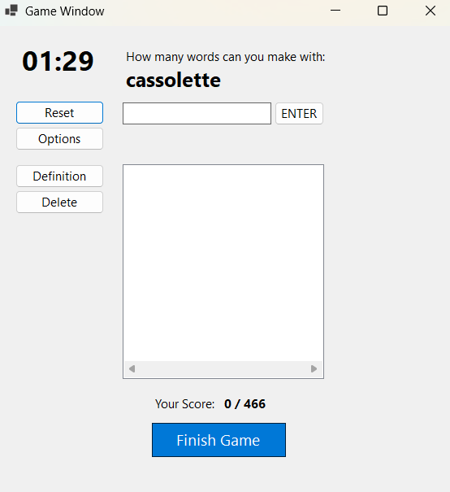
1.
2.
3.
4.
5.
6.

7.
8.

9.
10.

- Timer – If this reaches 0 then the game automatically ends.
- Reset button – Clears all the game’s statistics and gives the player a new prompt.
- Options button – Opens the options menu.
- The prompt
- The player input area – The player will type their guess into the text box and press ENTER on their keyboard or press the ENTER button to submit.
- The word list – All valid words typed during the game will appear here.
- Definition button – If this button is pressed when a word in the word list is selected, that word’s definition is displayed.
- Delete button – If this button is pressed when a word in the word list is selected, that word is deleted from the list and the score is decremented.
- Score – The total number of words listed during the game, compared to the maximum score possible.
- Finish button – Immediately ends the game.

Options Window
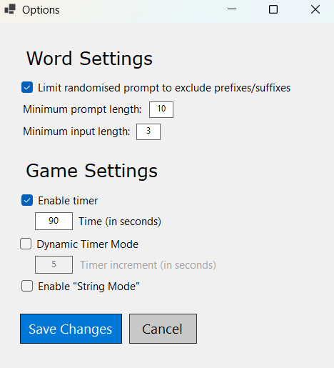

1.
2.
3.
4.
5.
6.
7.

- This option attempts to exclude words with specific prefixes and suffixes which would otherwise end up in giving the player a free word (e.g. plurals or antonym prefixes).
- This option specifies the minimum length of a prompt that the program could give to the player.
- This option specifies the minimum length of any input the player submits during a game.
- This option enables/disables a timer in game, adding an extra element of difficulty to the game. The timer will instantly end the game once it reaches 0. The starting value of the timer is specified in the text box below.
- This option determines whether each valid input increments the timer by the value specified in the text box below.
- This option determines whether each input must begin with the same letter as the last letter of the previous input.
- Saves all changes (this saves across sessions) or cancels all changes.

Flowchart Diagram
Form loads

Idle

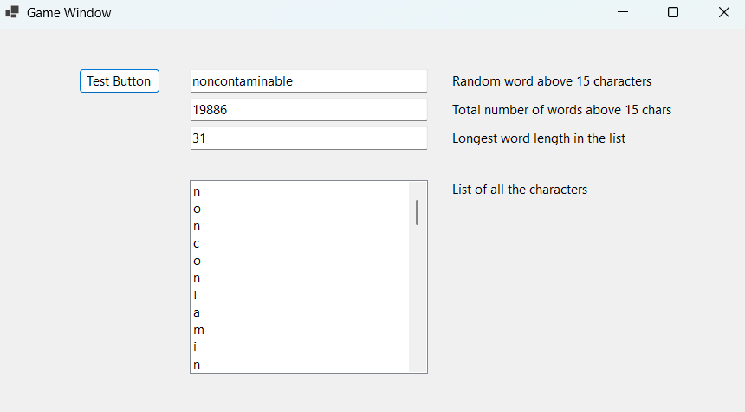
Figure 5
Figure 1 shows a screenshot of the main project code with only the basic file handling of the dictionary text file and basic string handling done so far. The program code shown takes a text file containing every English word in the dictionary from the source listed below, takes a random one that’s over 15 letters long, and displays it in the first text box

OVERVIEW:
The whole project will be coded in C# in a Windows Form Application. This is mostly so that a user interface can be designed to make the user experience more pleasant and make the program more accessible to more users. Additionally, file handling will be used to ensure data can be stored when the program is not running and to get data from external sources which is especially needed for the dictionary of all English words.

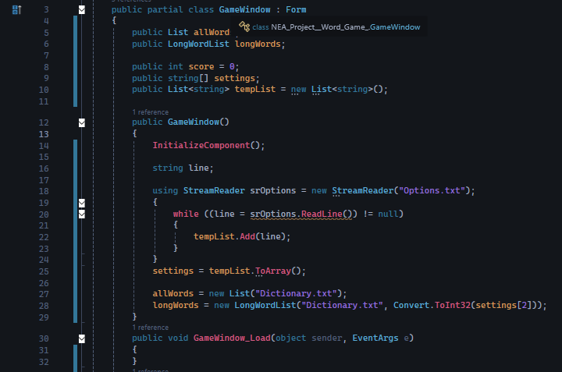
Figure 6
Figure 4 shows the constructor method of the main form – the Game Window – as well as the declaration of global variables. The first two lines contains an instance of Object-Oriented-Programming which we’ll get into soon [see later].
The “score” variable keeps track of the total number of words the player has inputted in a game – it increments by 1 each time a valid word is entered and is reset to 0 when the player starts a new game.
The “settings” array stores the value of each setting the player has input in the Options menu. This array took values directly from the Options text file “Options.txt” using the StreamReader file handling algorithm shown several lines below in the constructor method. During the development of this program, the number of total options there would be, and hence the size of the array, wasn’t concrete, and so to avoid out-of-bounds errors or options being off-sync, a temporary List variable was made to store all the values from each line in the Options text file, and then convert it to an array once the algorithm was done.
After the file handling algorithm, the program declares a new instance of the List and LongWordList objects to create an array containing every word in the English language for easy use and an array containing every word above a certain character limit threshold for a list of words to be used as the prompts. Both objects are based on the “Dictionary.txt” file containing every word aside from words containing non-alphabetic characters (e.g. hyphens, apostrophes), and the LongWordsList object requires an extra parameter stating the minimum prompt length in which the array will be based on. This parameter is simply the 3rd object in the settings array converted to an integer value because the value denoting the minimum prompt length will always be on the third line in the Options text file.

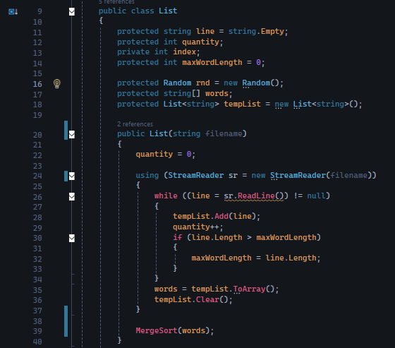
Figure 7
Figure 5 shows the constructor method and global variable declarations for the List class. The “quantity” variable will store the total number of words within the list, the “index” and “rnd” variables will be used for random number generation, and the “maxWordLength” variable keeps track of the length of the longest word in the list – this is mainly used for input validation and early testing. Similar to the constructor method of the Game Window, the total number of words in the text file isn’t concrete and hence a temporary list will be used to store each word on each line in the StreamReader algorithm and is converted to an array and stored in the “words” variable.
At the end of the constructor method, a Merge sort algorithm is initiated as the final list of words is unlikely to be sorted alphabetically perfectly, meaning that our searching algorithms down the line which depend on sorted arrays of data will not work properly.

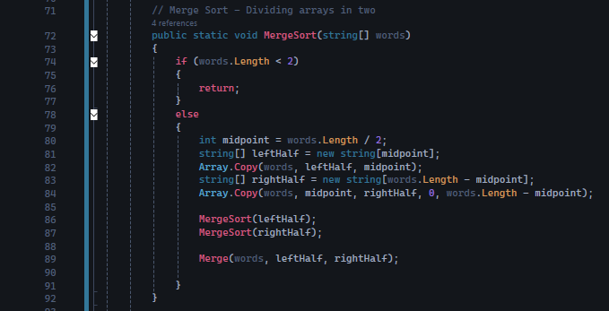
Figure 8
The merge sort algorithm is divided into two parts. The first part shown in Figure 6 is a selection statement determining if the array passed as a parameter contains more than one item. If it does, the program calculates the integer midpoint in the original array, uses it to create two new arrays of roughly equal size, and copies the half of the array to the left of the midpoint to one of the new arrays and the right half to the other. The program then calls the MergeSort subroutine again for each of the new arrays created, making for a recursive algorithm.
Once the arrays have been split into their smallest components, the program detects that the arrays have only one item and will immediately be returned for the program to call the next part of the sorting algorithm.
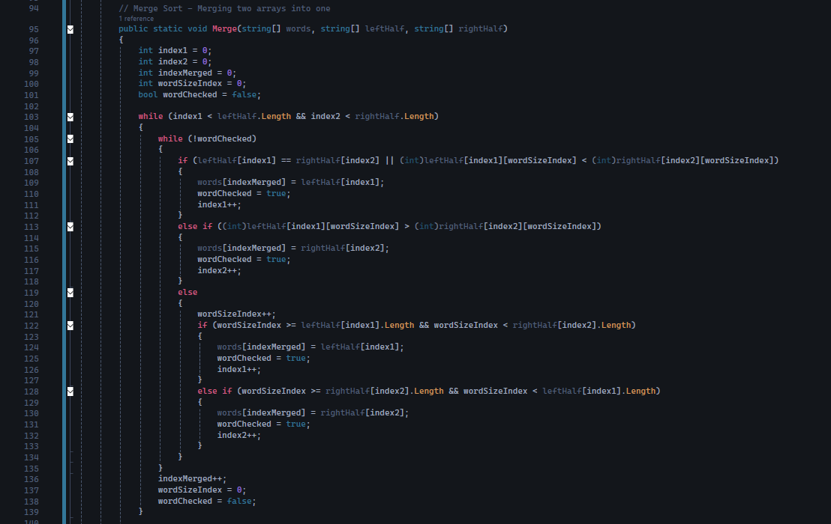
Figure 9
Figure 7 shows the second part of the Merge sort algorithm where two arrays get merged into one sorted array. During variable declaration, 3 indexes are declared each for the three arrays that are passed as parameters to this subroutine, and because we are trying to alphabetically sort words, one extra index is declared to allow for the program to iterate through and compare individual characters of each word and a Boolean variable is declared to deduce whether a comparison has been fully checked or not so the program can decide whether to continue iterating through the characters of both words being compared.
“index1” and “index2” refer to each of the two arrays being merged, starting at 0 and incrementing by one each time a word from the corresponding array gets moved to the merged array so the program always selects the lowest unmerged value in each array. This is also essential to ensure the first indefinite iteration algorithm only runs when there are unmerged words present in both unmerged arrays. The “indexMerged” variable refers to the merged array, also starting at 0 and incrementing by 1 each time a word from either two unmerged arrays gets moved to the merged array, so the program will always refer to the next blank spot in the array.
To sort a list of words alphabetically, the ASCII codes of the first letters of each word must be compared – the lower the ASCII code the earlier it appears in the alphabet and the earlier it should appear in the sorted array. Hence, the “(int)” algorithm was applied to the first letter of the words being compared to check which word would appear first alphabetically. If the two words began with the same letter, the “wordSizeIndex” variable would increment and the comparison would repeat but this time with the 2nd letter of the two words. This would continue until there’s a differing letter, or until the index exceeds the length of one of the two words being compared – in this scenario the shorter word would appear earlier alphabetically (so “humble” would appear before “humbleness”). This is reflected in the “wordChecked” variable, which is only set to “true” once a word gets moved into the merged array so the program can continue looping when the compared characters are identical. Once a word has been moved to the merged array, the wordSizeIndex is reset to 0 and the “wordChecked” variable is set to false again.
It’s especially important to note here that capital and lowercase letters have different ASCII values, meaning using the algorithm above a “G” would appear earlier alphabetically than a “d” since all capital letters use lower ASCII values than all lowercase ones. To prevent this, all the words entered in this program have been converted to lowercase using the “ToLower()” function, including during user input or when reading from text files.

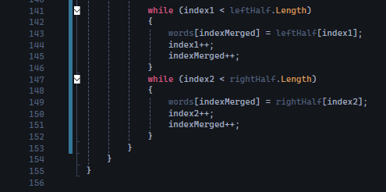
This is the last part of the Merge function, which only starts running once one of the two unmerged arrays have had all their words moved to the merged array. Due to recursion, what would be left in the latter array is already sorted because the “unsorted” array is the result of either the merging of two other unsorted arrays or simply arrays of one size. In both cases, we’ve already run comparisons and we know that everything left in the unsorted array appears later in the alphabet than everything that has already been moved into the sorted array, so the program iterates through each remaining item in the unsorted array and adds them to the sorted array. These sorted arrays are passed back repeatedly to be merged with other sorted arrays into bigger arrays and eventually the whole list of words is sorted alphabetically.

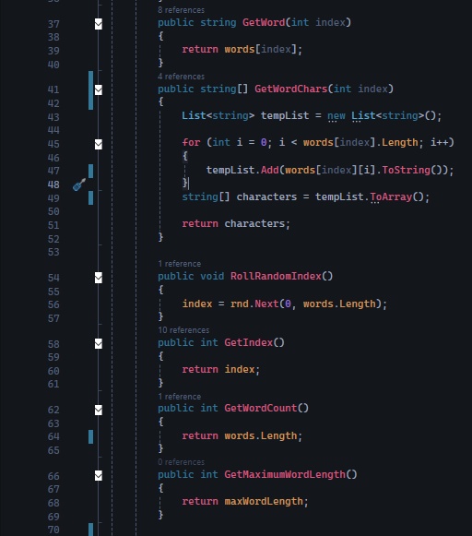
Figure 10
Figure 8 shows the procedures of the List class. The “GetWord” procedure returns the word at the specified index, the “GetWordChars” procedure returns the array containing each individual character in the word specified in each item in the array, the “RollRandomIndex” procedure simply generates a new random number and stores it in the “index” variable, the “GetIndex” procedure simply returns whatever value is stored in the “index” variable, the “GetWordCount” procedure returns the number of words in the list of total words, and the “GetMaximumWordLength” procedure returns the length of the longest word in the array.
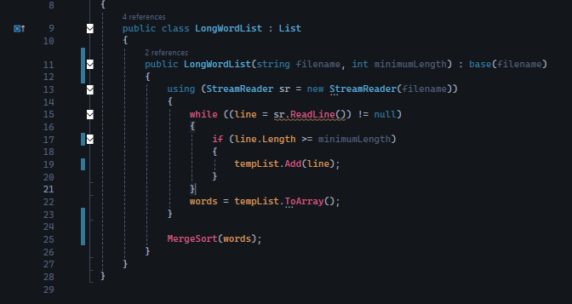
Figure 11
Figure 9 shows the LongWordList class, which is inherited from the List class. The only difference between these two classes is that the former passes an extra integer variable which is used as a threshold for making an array of words using only words longer in length than the specified threshold. This acts as the list of possible prompts for the player.

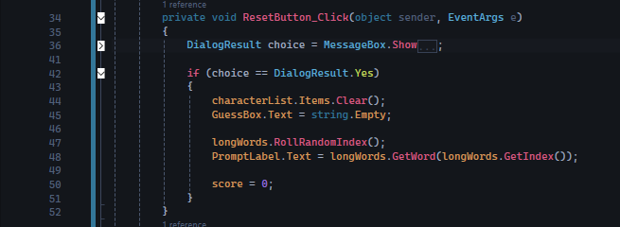
Figure 12
Figure 8 shows the procedure called when the “Reset” button is pressed. At first, a confirmation message pops up for the user to confirm their choice (this is to prevent misclicks from wasting the user’s time). If the player presses “Yes”, the program will clear all the items in the word list that the player has entered, resets the text in the Guess text box back to an empty string, resets the score back to 0 and rolls a new random prompt and displays it on the game screen.

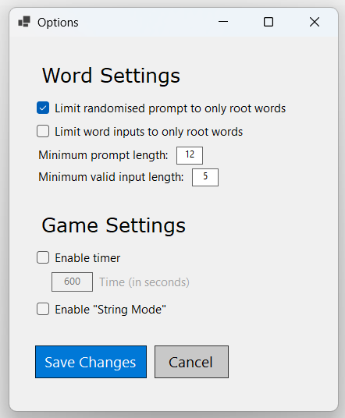
Figure 13
Figure 4 shows the Options menu. It is a separate menu which is displayed upon clicking the “Options” button at any point in the program. Each setting has been categorised into two sections: options that affect the words in play, and options that affect each game itself. These options can be changed at any time (even in the middle of a game), but the player must start a new game for any changes to take effect.
The player can change any of these settings as they will (as long as input validation ensures no egregious values are entered in the text box-based settings), and must press “Save Changes” for any changes they made to be saved and stored by the program. These settings save across sessions, even after the player closes the program. If the player presses “Cancel” or forcefully closes the menu, none of the changes are saved.

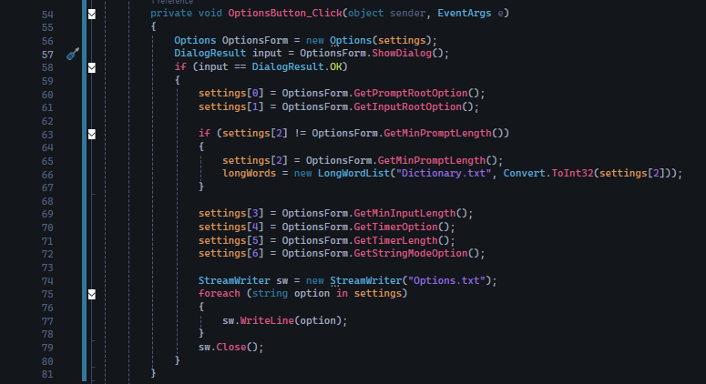
Figure 14
This subroutine shown in Figure 4 detects whether the Options button is pressed at any point in the program.
The first line creates a new instance of an Options form every time it is pressed. This is to ensure the class executes its constructor method each time to properly display the settings and to ensure the program doesn’t crash when the user forcefully closes the menu and tries to reopen it. The constructor method and the rest of the Options Form class will be shown below.
The second line displays the Options menu itself. Note that we are using the “ShowDialog()” method so we can get a value from user input on the Options form and storing it in the “input” variable. This is also to ensure that the user cannot interact with the Game Window form while the Options menu is open – the player must exit the menu in order to continue interacting with the rest of the program. This is useful to prevent the user from accidentally forgetting that they have the menu open and potentially prevent the user from opening more than one Options menu at once.
The next line is a selection statement determining if the player pressed specifically the “Save Changes” button. This button’s “DialogResult” attribute has been set to “OK”, meaning whenever the player presses it, the program will store “DialogResult.OK” into the “input” variable and automatically closes the form. Additionally, the “Cancel” button stores another non-default DialogResult value, which will automatically close the menu even if the button isn’t linked to any block of code. If the selection statement is true, the program begins fetching the data from each of the options in the menu and stores it into the corresponding memory location in the “settings” array. It then ends by overwriting the old Options text file with the new data, ensuring that when the Options menu is opened again, the new data is stored instead. This effectively creates a simple “save” system, where the program can save settings across different sessions.
Note how the program performs a selection statement to determine if the option for whether to make the prompts limited to root words or if the option for the minimum length of the prompt has been changed or not. This is crucial because if either has changed, a new instance of the “longWords” class must be made to ensure that for any future games the list of possible prompts the program could give to the player is accurate to the settings they set for it. The user having to close the program and reopen it again just so they can allow 10 letter words as prompts is not a user-friendly design and it is not convenient.

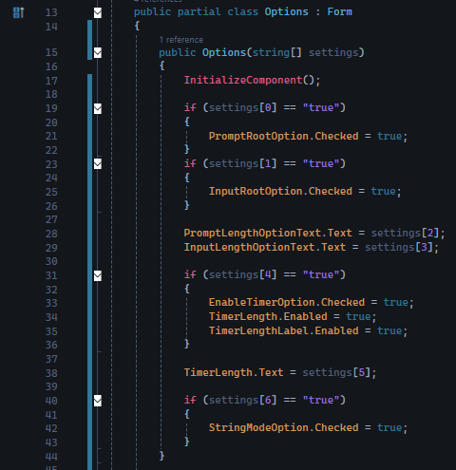
Figure 15
Figure 4 shows the constructor method for the Options form, with the “settings” array from the GameWindow form being passed as a parameter to this method. Here, when the instance of the Options window is being created, the program iterates through each of the different items in the settings array (corresponding to each line in the Options text file) and displays the currently selected settings accordingly.
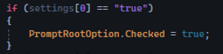
For example, this first selection statement checks whether the program has read from the options text file the setting for limiting the prompt to only include root words has been enabled or not, and thus whether the player has this option selected. All checkbox-style options (those which only carry a “true” or “false” value) are set to “false” by default, so we only need to check if during the last session the player had it enabled. If so, the checkbox displays a check to show that the setting has been enabled, before the program displays it to the player.
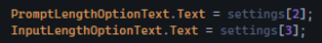
For the input-based settings, it’s even simpler. The program is simply taking what value was stored in these settings in the last session and displaying those values in the corresponding text box in the options menu.

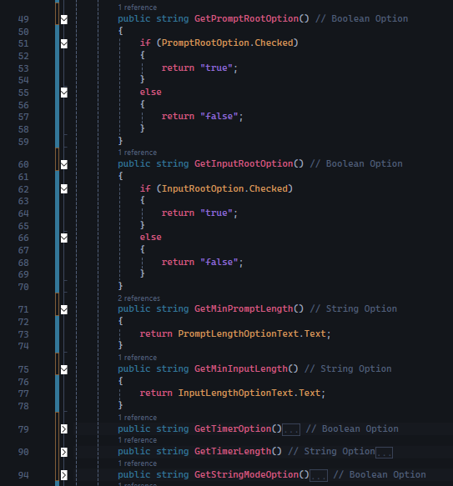
Figure 5
Figure 5 shows methods in the Options form class to return the values stored for each option in the Options menu. Because Boolean values cannot be easily stored as text, for the Boolean options as we shall call them from now on (those that only take a “yes” or “no” value), the program must perform a selection statement to return “trues” and “falses” as strings rather than simply returning the Boolean itself. For string options however simply returning whatever value is stored in the input boxes is viable – they’re all stored as strings and would have no problem going into a text file. Of course, input validation is required to ensure the user does not enter any egregious values (in the case of the prompt’s minimum length, egregious entails anything that contains a non-numeric character).

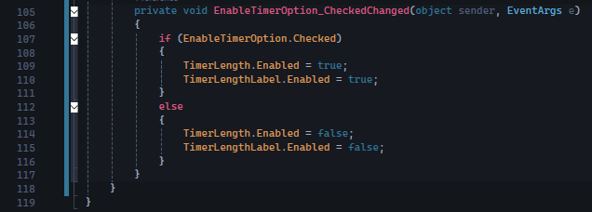
Figure 6
There is another caveat to this class though. This isn’t outlined anywhere in our list of objectives, but it’s a nice feature to have to help with user friendliness. You may have noticed in the screenshot of the Options window, the “Enable timer” option was linked to another text box allowing the user to input the length of the timer, and if the former option was disabled the text box was impossible to edit. The subroutine shown in Figure 6 detects whether this option was checked, and if so, it ensures that the “Timer length” option becomes editable when the former option is enabled, and not editable otherwise.

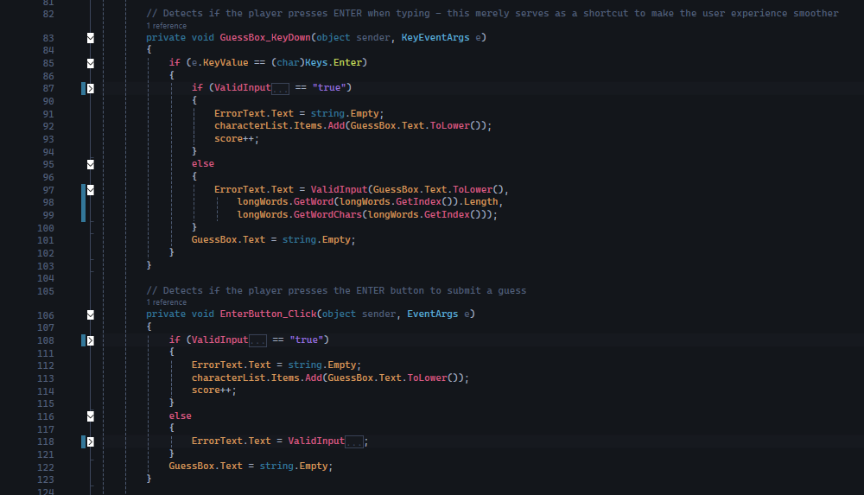
Figure 16
Figure 14 shows two procedures which are both functionally identical. The first one detects if ENTER has been pressed when typing in the input text box and the second one detects whether the “Enter” button has been pressed beside the input text box. The program runs a selection statement which calls a subroutine to determine whether the inputted string is valid or not. If it is, the program will hide any error message that was displayed from a previous input, increments the score and adds the inputted string to the list of words below the input text box. If it isn’t the program will display a red error message below the text box describing the issue. In both cases, the text box’s contents is emptied.

Testing

Test 2
This test aims to cover every Category 2 objective, which is centred around the overall game function. It will involve playing a normal game each with different settings (including different combinations of settings) and with each game, basics – such as input validation and score tracking – as well as more advanced mechanics such as web-scraping.

2.1
This test is focused on basic input validation in a standard game with default settings (3 letter minimum input length). The expectation with this test is that the program should be able to correctly identify whether an input contains only letters, is a word in the dictionary, contains characters only found in the prompt (quantity taken into account), is longer than the minimum input length, isn’t the prompt itself and hasn’t already been inputted. The program should increment the player’s score and add the guess to the word list below if all the conditions above are satisfied, and it should display an appropriate error message and reject the input otherwise.

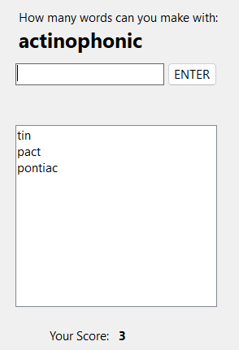
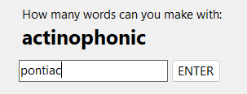
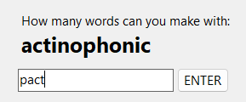
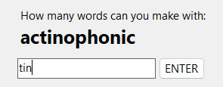
Every word here are valid inputs, they all do not contain letters not found in the prompt and are all words in the dictionary. The program here correctly accepts them as inputs, adds them to the word list and increments the score.

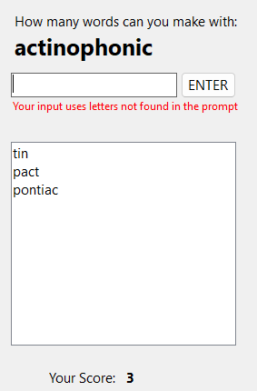
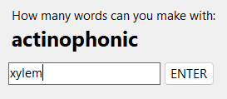
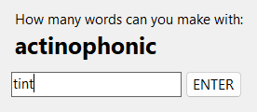
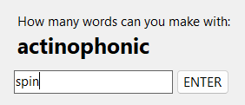
Every word here are invalid inputs. “spin” is a boundary value where it would be a valid input without the first letter. “tint” is also a boundary value where all of the letters are found in the prompt but ‘t’ occurs more in “tint” than in the prompt. “xylem” is an egregious value; none of the letters are in the prompt.
Here, the program correctly identifies that the letters in the inputs are not found in the prompt and displays the error message correctly. It does not add any of the inputs to the word list and does not increment the score.
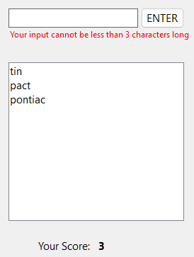
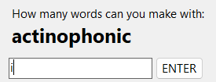
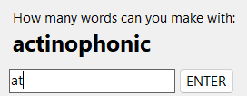
Here, the program correctly identifies that the two words inputted here are too short. The program does not add them to the word list and does not increment the score.

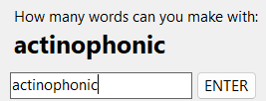
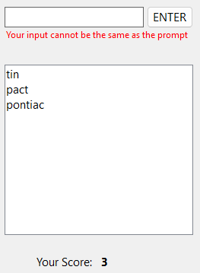
Here, the program correctly identifies that the input is the same as the prompt. No credit is given to the player here.

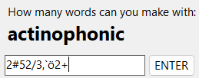
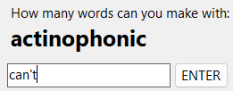
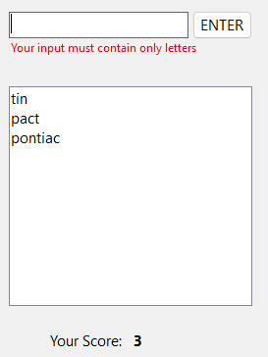
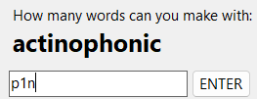
Here, the program identifies that each of the inputs here contain a non-letter character. “p1n” and “can’t” are boundary values while the bottom value is an egregious one. In all cases, the program returns the appropriate error message, and the score is not incremented.

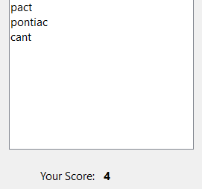
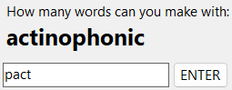
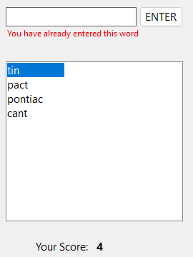
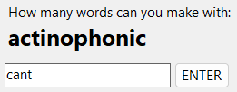
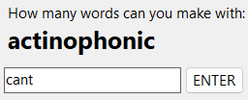

After all these boundary/egregious tests it’s important to ensure the program still accepts new words correctly (to test whether variables have. The word “cant” is a valid word found in the dictionary (not to be confused with “can’t”) and the program correctly accepts it, adds it to the word list and increments the score. The next two inputs are words that have already been entered earlier, and this time the program identifies that they have already been entered. The program displays the appropriate error message, does not add to the word list and does not increment the score.
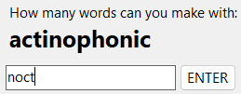
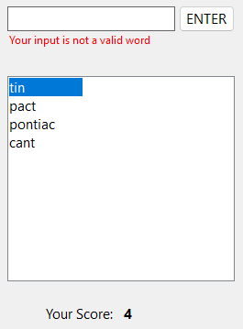
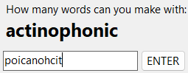
Lastly, these two inputs fit all of the criteria outline above, but aren’t actually real words in the dictionary. “noct” is a boundary value – it sounds like a real word. “poicanohcit” is an egregious value, it sounds nothing like a word while using valid letters.

With each of the inputs above and their respective outcomes, it can be concluded that the expectation of this sub-test has been met.

Evaluation

List of objectives – Reflection
- -
- -
- -
- -
- - With Test 2.1 meeting the expected outcome, the objectives 2.5.1, 2.5.2, 2.5.3, 2.5.5 and 2.5.6 have been achieved.
- - With Tests 2.1 and 2.2 both showing the interface when a valid/invalid guess has been submitted, and both have proven to have meeten the expected outcome, this objective is declared to have been achieved.

Research (organise this later)
The question that I want to answer | Where I got this information from | Primary or Secondary? | Why I want to get this information
How to code in HTML | w3schools | Secondary | I learnt this so I can learn how to develop a simple website.
How to structure a website and get basic functionality | Microsoft Tutorials | Secondary | I learnt this so I can learn how to develop a simple website.
To create an static array of an unknown size | https://s]tackoverflow.com/a/4078650 | Secondary

C# Tutorial - SuperSimple TCP/IP Client Server | FoxLearn - YouTube

Mastering TCPListener in C#: Building Network Applications from Scratch

https://www.youtube.com/watch?v=74B6j4LJ93I
https://www.youtube.com/watch?v=PSFESmqVtRE
https://www.youtube.com/playlist?list=PLbDsRCGLbN1_-ZWS6G5ionKox0Ahrdv_H
https://www.youtube.com/watch?v=gxkdJRNym-g
https://www.youtube.com/watch?v=YX3zXHhzg4g

GitHub - dwyl/english-words: :memo: A text file containing 479k English words for all your dictionary/word-based projects e.g: auto-completion / autosuggestion

Bibliography
Juho Hamari, J. K. (2014, January). ResearchGate. Retrieved from Does Gamification Work? — A Literature Review of Empirical Studies on Gamification: https://www.researchgate.net/publication/256743509_Does_Gamification_Work_-_A_Literature_Review_of_Empirical_Studies_on_Gamification

